World Language Department 8/12/15
Hough International Week 2016
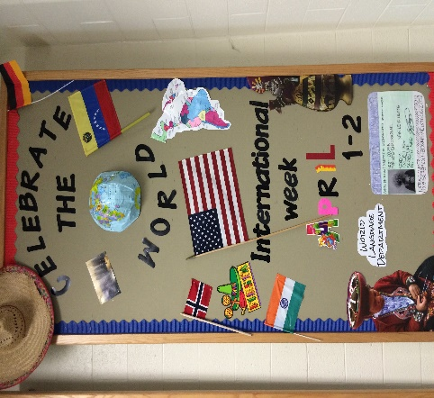

Upcoming Events

October 30
International Week Website

November 30
Preliminary IW plan + activities

December 18
Final IW plan + activities
Global Education Resources:
http://worldview.unc.edu
http://www.globalteachereducation.org
http://ciu.northcarolina.edu
http://growingupglobal.net

Recommended Video:
http://startempathy.org/

April 4-8
Theme: Building Wider Perspectives
Main Event:
Dear staff, Welcome back!
Our 1st IW 2014-2015 celebrations and awareness activities were a total success! Thank you for your support and engagement. ¡Gracias! Merci!
An ideal window of incredible opportunities to collaborate and embrace culture in our school, is around the corner again.
Here you have some focus questions that you may find useful to read in your PLC to plan your activities this year.

Focus questions:
- How do we authentically engage in the world?
- How do we understand and celebrate the various cultural backgrounds represented in my classroom/office?
- What is the cultural landscape of my classroom/office and where are the gaps?
- Why is Cultural Intelligence important?
- What’s my next step?
Teach with Cultural Intelligence - Carrie Wagner

What is the International Awareness Week?
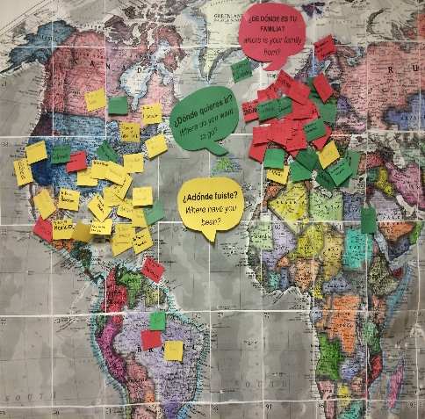

What is Empathy?

Write your definition here.

Every April, schools and other learning institutions across the United States celebrate World Language Week or International Week. It is a great opportunity to promote cultural celebrations and diversity awareness in our classes and in our school. It is also a great advocacy opportunity for the World Language department.

What are the goals of an International Week at Hough HS?
- To promote cultural celebrations and diversity awareness in our school and community.
- To create advocacy opportunities for the students, departments and school community.
- To identify people willing to plan and execute Hough 1st International Week during 2015-2016.
- To make connections with our school multicultural population so that together, we create a school environment of empathy, appreciation, kindness, tolerance and compassion towards diversity.
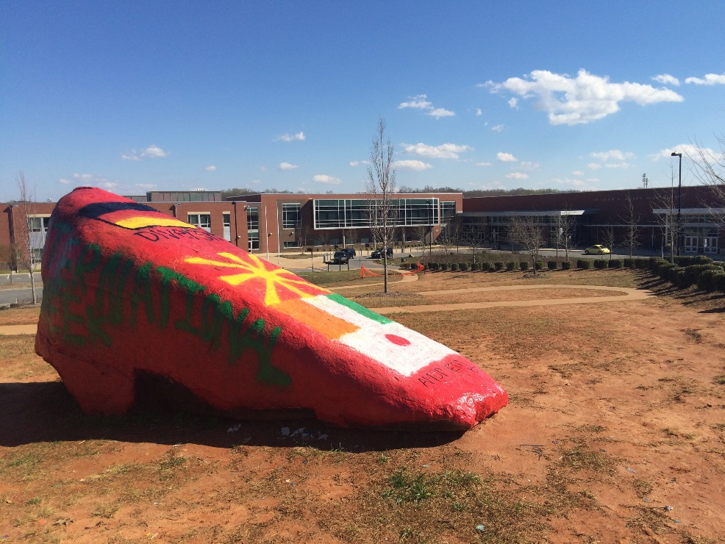
HOUGH 1ST INTERNATIONAL FESTIVAL APRIL 2017

Global adventures begin right where
we live!

